CODING AND SOLUTION

|  |  |
| --- | --- |
| Team ID | PNT2022TMID45278 |
| Project Name | Real-time river water quality monitoring and control system |

FINAL FEATURES

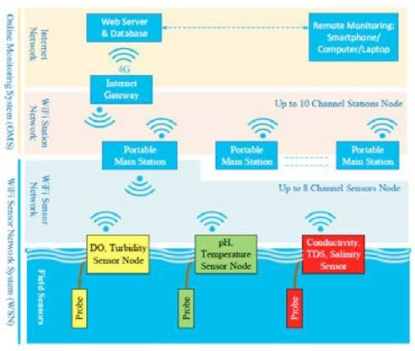

**NETWORKING SYSTEM**

* User can view the turbidity of a water through the sensor in this application.
* User can view the pH level of a water through the sensor in this application.

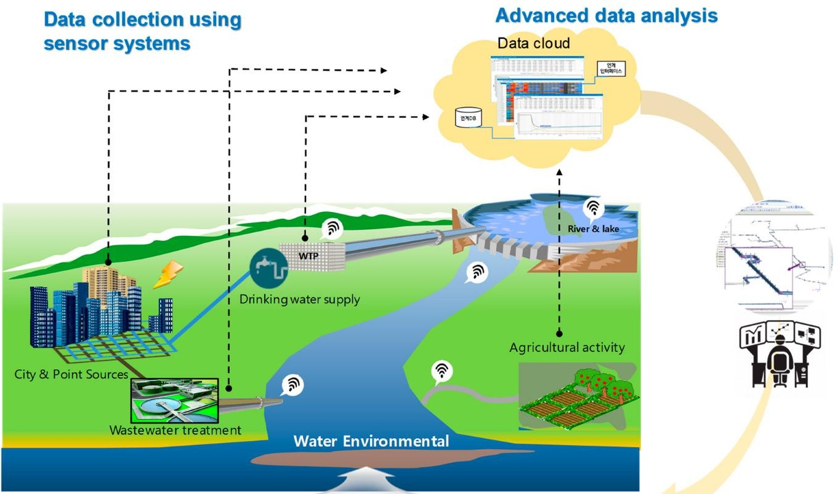

**CONTROL FLOW DIAGRAM**

* + User can view the temperature of both water & motor through the sensor in this application.
  + User can access / controlling the motor functionalities.

